

**Digitisation pricing**

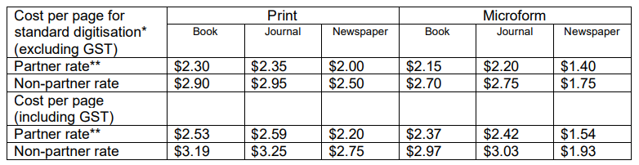

*Standard digitisation costs apply to material not requiring special handling or preservation treatment. Different rates apply to oversized, fragile, damaged, or otherwise non-standard material.

**To receive the Partner rate, you must be a financial member of Trove Collaborative Services.